The Scope of the Work.

(Describe Current situation)

The current situation so far is that blooming marvelous Florist in Blarney has a website called http://www.corkflorists.ie.

They have also been running two shops in Ireland since 1968. The stores are located in Blarney Co. Cork and Tower, Blarney Co. Cork.

These businesses used to have a very good online store with loads of orders, but that changed due to an update two years ago. The main problem is that when it comes to the PayPal function of sending the flowers to a different address than that of the billing address.

* From the interview the owner also told us that users found the website boring but that is a nonfunctional requirement.
* The paypal fix is done but changing a setting in paypal’s settings . By clicking all shipping address.

The context of the work

(Create a Context Diagram)

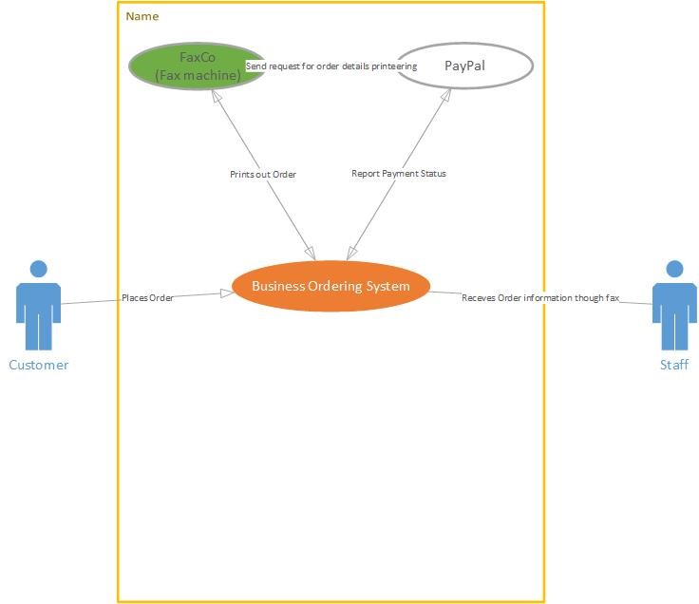

Work Partitioning

(Create an Event List)

# Happy scenario

* The customer goes on to the website
* Picks an item Is brought to PayPal
* Enters details such as credit card and address to send to.
* PayPal process the order
* Emails are sent to customer and staff
* Faxco sends a fax to the staff in the shop.
* The staff make up an order Deliver to customer, smiles all round.

# Wrong Scenario

* The customer goes on to the website
* Picks an item Is brought to PayPal
* Enters details such as credit card and address to send to.
* Wrong details entered, asked to try again.

# No funds scenario

* The customer goes on to the website
* Picks an item Is brought to PayPal
* Enters details such as credit card and address to send to.
* No money in credit card or PayPal credit.
* Asked to enter other details.

# Specifying a BUC

(Create a business Use case specification for any three event responses.)

|  |  |
| --- | --- |
| USE CASE NAME: | Buy Flowers |
| USE CASE ID: | BF-001 |
| PRIORITY: | High |
| SOURCE: | Requirement - BF-R1.00 |
| PRIMARY BUSINESS ACTOR: | Online customer |
| OTHER PARTICIPATING ACTORS: | PayPal system, |
| OTHER INTERESTED STAKEHOLDERS: | Customer’s bank |
| DESCRIPTION: | Allows customers to buy flowers online |
| PRE-CONDITION: | Must have PayPal account or credit card |
| TRIGGER: | Buying flowers |

# Happy scenario

|  |  |  |
| --- | --- | --- |
| TYPICAL COURSE OF EVENTS: | Customer Action | System Response |
| Step 1: | Customer goes to web site | System displays main screen |
| Step2: | Customer selects flowers to buy by clicking on ‘Add to Cart’ button | System displays shopping cart page |
| Step 3: | Customer proceeds by clicking ‘checkout with PayPal’ button | System displays order summary and PayPal login form. |
| Step 4: | Customer types in login details and confirms by clicking ‘Log In’ button | System displays final confirmation dialog box from PayPal. |
| Step 5: | Customer confirms payment details | System displays successful transaction message |

# Wrong Login details scenario

|  |  |  |
| --- | --- | --- |
| TYPICAL COURSE OF EVENTS: | Customer Action | System Response |
| Step 1: | Customer goes to website | System displays main screen |
| Step2: | Customer selects flowers to buy by clicking on ‘Add to Cart’ button | System displays shopping cart page |
| Step 3: | Customer proceeds by clicking ‘checkout with PayPal’ button | System displays order summary and PayPal login form. |
| Step 4: | Customer types in wrong login details | System displays error message and prompts for retype login details or pay with credit card |
| Step 5: | Customer clicks on ‘Pay with credit card’ | System displays Credit card payment form. |
| Step 6: | Customer enters credit card details | System display confirmation dialog box. |
| Step 7: | Customer confirms payment details | System displays successful transaction message |

# No money on credit card account

|  |  |  |
| --- | --- | --- |
| TYPICAL COURSE OF EVENTS: | Customer Action | System Response |
| Step 1: | Customer goes to web site | System displays main screen |
| Step2: | Customer selects flowers to buy by clicking on ‘Add to Cart’ button | System displays shopping cart page |
| Step 3: | Customer proceeds by clicking ‘checkout with PayPal’ button | System displays order summary and PayPal login form. |
| Step 4: | Customer types in login details and confirms by clicking ‘Log In’ button | System displays final confirmation dialog box from PayPal. |
| Step 5: | Customer confirms payment details | System displays error message stating insufficient amount of money on the account. Prompts for change the order |
| Step 6: | Customer changes order or leaves the system | If customer changes order system goes back to step 2.  If customer leaves system displays ‘good bye’ message |

|  |  |
| --- | --- |
| CONCLUSION: | None |
| POSTCONDITION: | Customer PayPal/credit card account is debited |
| BUSINESS RULES | In order to pay online customer has to have PayPal account or credit card |
| IMPLEMENTATION CONSTRAINTS AND SPECIFICATIONS | None |
| ASSUMPTIONS: | None |
| OPEN ISSUES: | None |

# Home Page

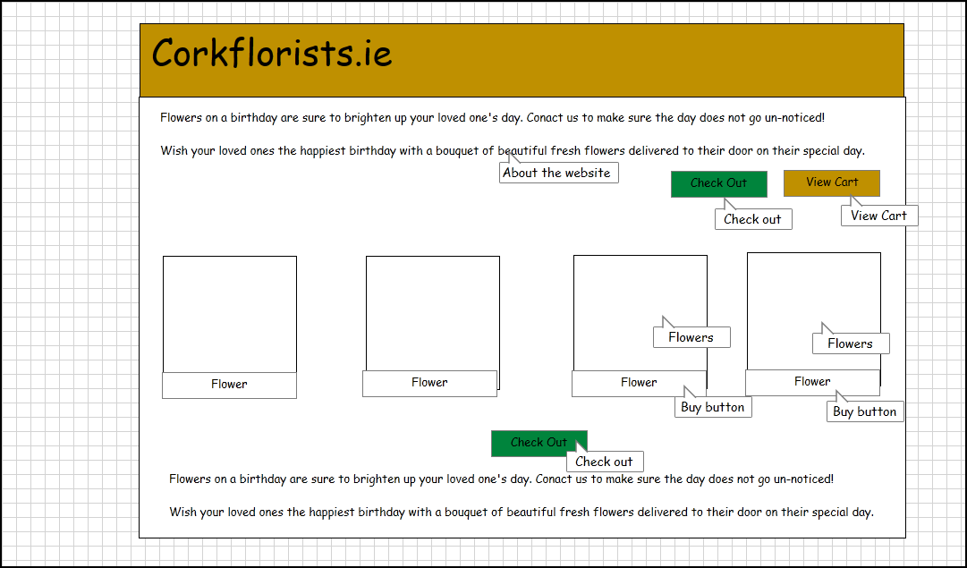

# Checkout Detail Page

